## 

## 

## 

## 

## 

## 

# **Project Reptile**

## 

## 

## 

## 

## 

## 

## 

## 

## **1. Introduction**

### **Purpose**

The purpose of this document is to provide a detailed description of the software architecture of the game. This document is intended for use by developers, testers, project managers, and stakeholders to ensure the software meets the defined requirements.

### **Scope**

The game Project Reptile is designed to be played in under an hour on a desktop computer, similar in time and scope to Solitaire. The system will be deployed as a C# WinForms app available for download.

### **Overview**

This document is organized as follows:

* **Section 2**: Overall Description
* **Section 3**: Game Mechanics
* **Section 4**: User Interface
* **Section 5**: Art Direction
* **Section 6**: Class Hierarchy and Software Architecture

## 

## 

## 

## 

## 

## **2. Overall Description**

### **Product Perspective**

The game Project Reptile is a fantasy game set in a world based on the works of author HP Lovecraft. Many of his creations and stories are in the public domain and are freely available to use for assets and themes. The mechanics of the game are based off of Quenzar’s Caverns, a game which was released on Windows 3.1 alongside Solitaire and Minesweeper, and borrowing many features from the latter. The game can be described as a hybrid of a traditional dungeon crawler with a Minesweeper-inspired trap element. Currently, no game using these mechanics is available on desktop or mobile devices. This iteration of Project Reptile will be released for Windows Desktops, but in the future it will be adapted for a mobile release.

## 

## 

## 

## 

## 

## 

## 

## 

## 

## 

## **3. Game Mechanics**

Project Reptile will be a Dungeon Crawler with Minesweeper-inspired puzzle elements. Game features will include:

* A 10x10 randomized dungeon grid for exploration. The player can encounter enemies, landmarks, or both on each tile of the dungeon. Enemies can be fought for loot and landmarks can be searched for treasure. Upon traversing a tile, the player will see a number displayed at their location, telling them how many traps are placed on neighboring tiles.
* Over 20 enemies inspired by the works of HP Lovecraft, each with original artwork developed for this game. Each game features a random assortment of enemies and bosses so each game will be a unique struggle.
* A wide selection of over 30 items to outfit your character with. Find the best gear for a chance to best the boss!

## 

## 

## 

## 

## 

## 

## 

## 

## 

## **4. User Interface**

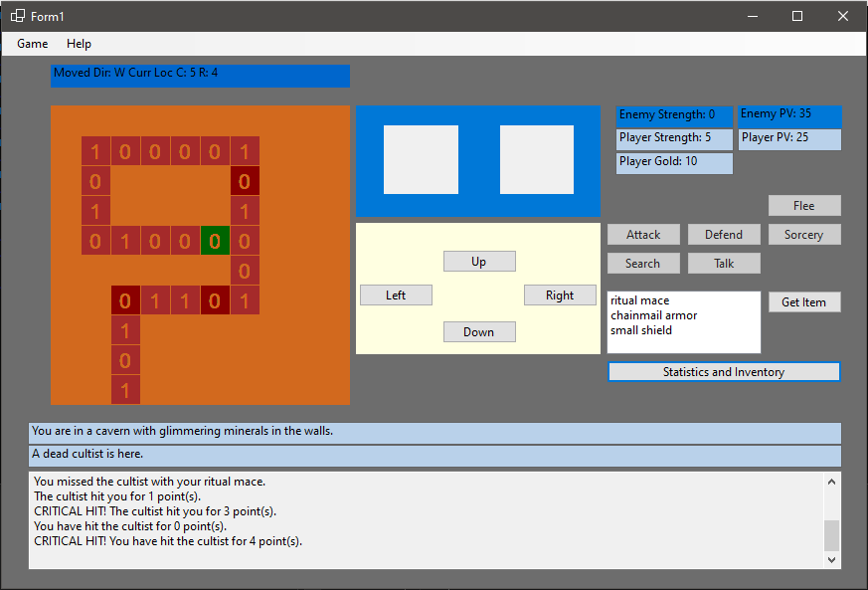

This is the current user interface, which will be redesigned further into the project. Right now, all buttons function as desired except the “Sorcery” button, the “Flee” Button, and the “Talk” button. Every function and element is finalized, although their place on the screen and whether or not they are permanently displayed may change.

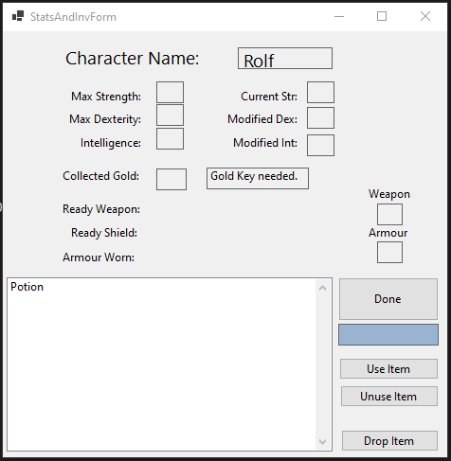

This is the Statistics and Inventory submenu. Items picked up by the player display correctly, but everything else is just a placeholder at the moment. Everything is named neatly and set up to be wired to the player class very soon.

## 

## 

## 

## 

## **5. Art Direction**

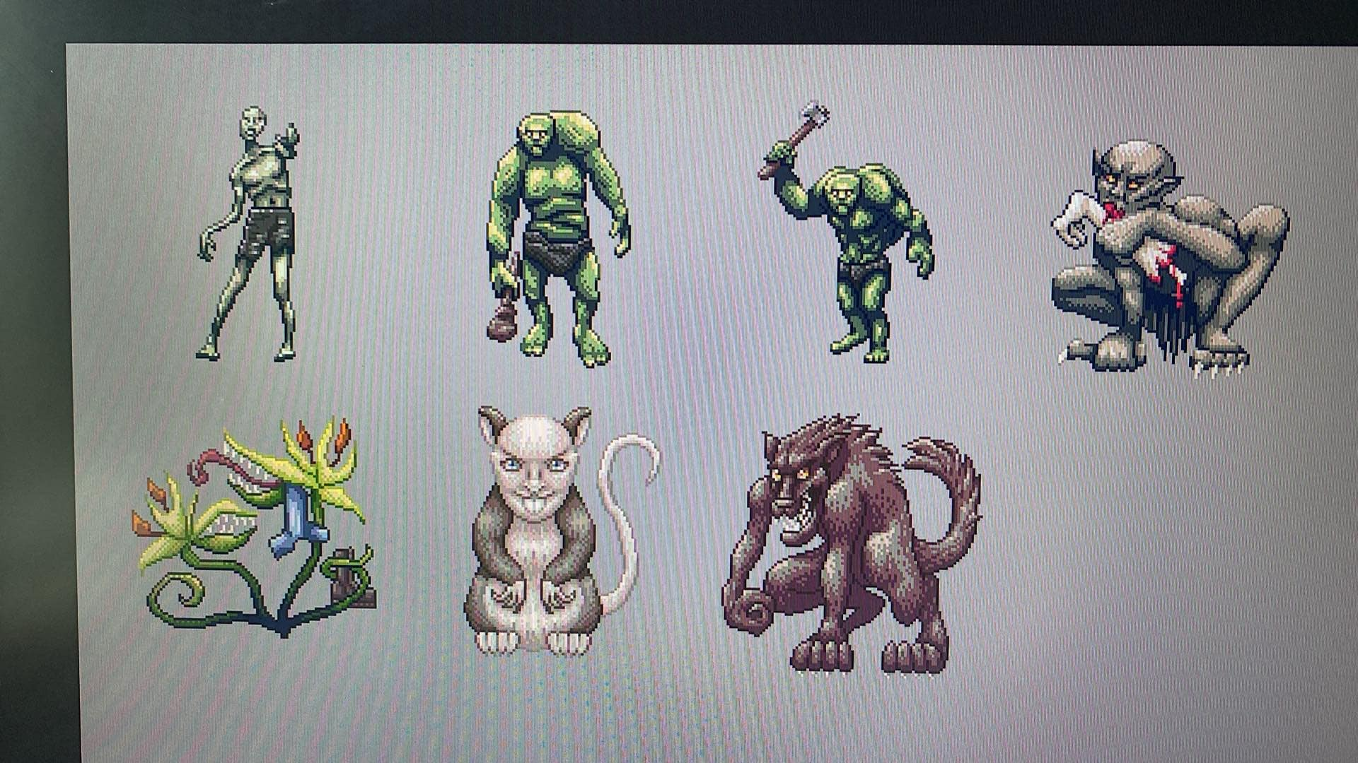

I am collaborating with an artist on making images to represent the different enemies and landmarks the player can encounter in the game. We are using a style inspired by 16-bit game consoles, and trying to maintain a spooky vibe, rather than a more mature horror theme.

## 

## 

## 

## 

## 

## 

## **6. Class Hierarchy and Software Architecture**

I believe explaining the interactions between my various game objects will be the most difficult, and have saved this part for last because of this fact. In order to explain this in the future for my presentation, I will have a UML Class Diagram showing how my game objects interact, a discussion of how I am using lists and helper functions to retrieve my in-game objects when required, and how the data-layer and UI-layer are seperated.